Q1]

The code mainly comprises of these three crucial steps:

* Building the Convolutional Neural Network (CNN) Model:

1. A CNN model is constructed using the Keras Sequential API.
2. It consists of several Conv2D layers with activation functions, max-pooling layers, a dense layer, and a final softmax activation layer.
3. The model is compiled with the specified loss function, optimizer, and metrics.

* Training the Model:

1. The model is trained using the fit method with the training data.
2. Training history (accuracy and loss) is stored for visualization.

* Model Prediction and Testing:

1. The trained model is used to predict the labels for the entire training dataset.
2. An example prediction is shown by displaying an image along with its predicted label.

Output:

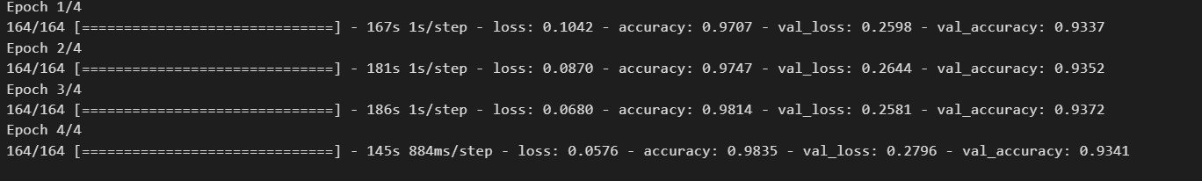

For 4 epochs average accurage is 98%.

Test for letter C

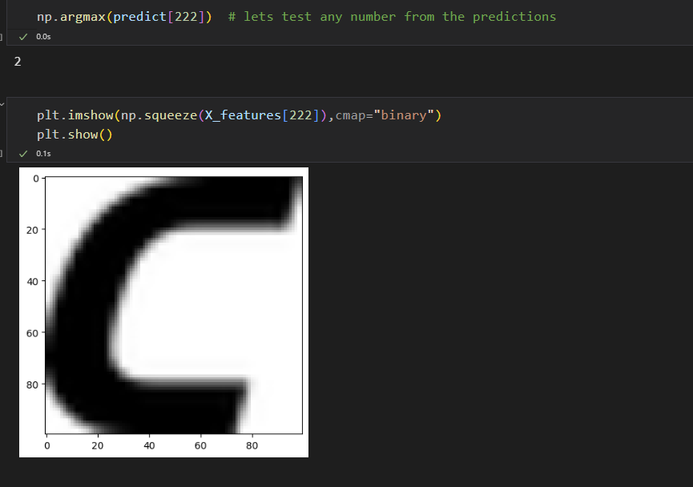

Q2]

Approach: The code mainly comprises of three parts Data Visualization and Splitting, [Logistic Regression Model](https://en.wikipedia.org/wiki/Logistic_regression) and Model Evaluation.

Data Visualization:

Various visualizations are created to explore the relationships between different features and the target variable 'chocolate'.

Visualizations include count plots, box plots, and heatmaps to gain insights into the data.

Data Splitting:

The dataset is split into features (X) and the target variable 'chocolate' (y).

The train_test_split function from scikit-learn is used to divide the data into training and testing sets.

Logistic Regression Model:

The Logistic Regression model is chosen for this classification task and imported from scikit-learn.

The model is initialized (logmodel) and then fitted with the training data using fit().

Model Evaluation:

The coefficients of the logistic regression model are printed to understand the importance of each feature.

Predictions are made on the test set using the predict() method.

Classification report and confusion matrix are generated to evaluate the performance of the model.

A heatmap is created to visualize the confusion matrix.

The accuracy score of the model on the test set is calculated and printed.

Ouptut:

